**Worksheets**

**Mechanical Waves Unit Test** Total questions: 20 Worksheet time: 26mins

Name Class Date



1. What is the velocity of a wave with a frequency of 1.8 Hz and a wavelength 3.6 m? v = λf
2. Label the point with an antinode.

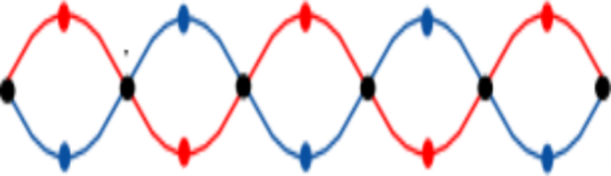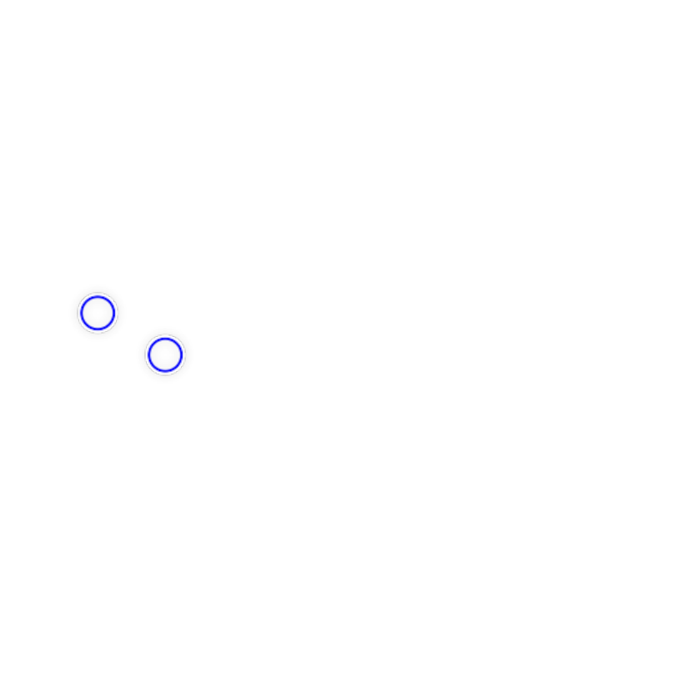

A

B

1. Label the point with a node.

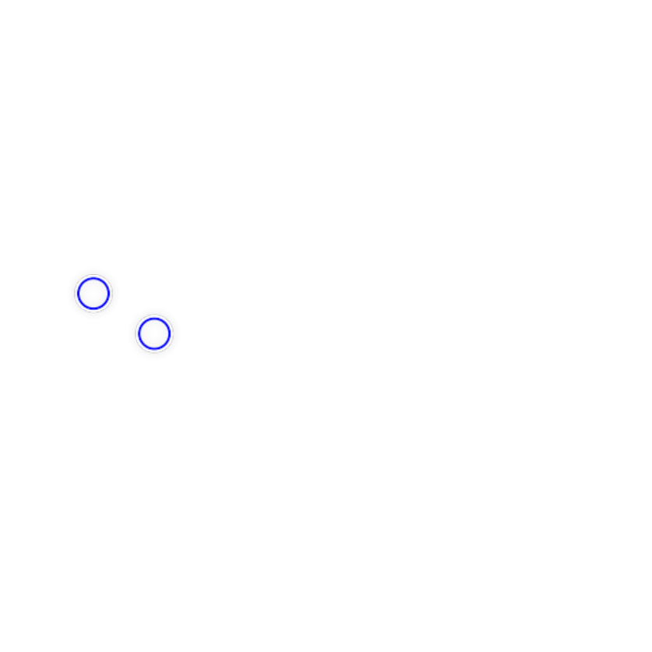

A

B

1. Which of the following is NOT a type of mechanical wave?
2. Draw two waves with the SAME amplitude. One has high frequency, and one has low frequency.



1. Match the following definition to the correct explanation.

Constructive Interference 

The total amplitude of the waves is

 equal to the sum of the amplitudes of the individual waves.

Law of Superposition 

Two waves with the same frequency and phase.

Destructive Interference 

Two waves with the same frequency and opposite phase.

1. The pitch of a sound is related to the...
2. A wave pulse is created in a Slinky. It takes 1.5 seconds to travel the length of the Slinky. If the Slinky is

8 meters long, what is the speed of the wave? v = λ

T

1. The unit that compares the intensity of sound is called...
2. When the frequency of a wave increases, what happens to the wavelength?
3. The Effect refers to the change in observed frequency during the relative motion between a wave source and its observer.

Ans.

1. 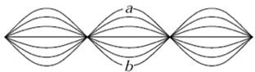​

A string is clamped at both ends and plucked so it produces a standing wave as shown above. How many nodes and antinodes are there?

1. Waves are a transfer of what?
2. Patterns are only created within the medium at specific frequencies/vibration. These frequencies are known as...
3. 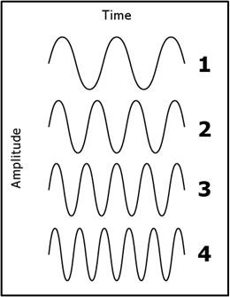​

Which transverse wave has the highest frequency?

1. 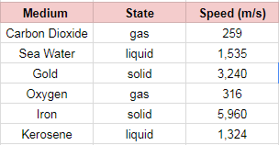​

Which statement can be made based on these data?

1. 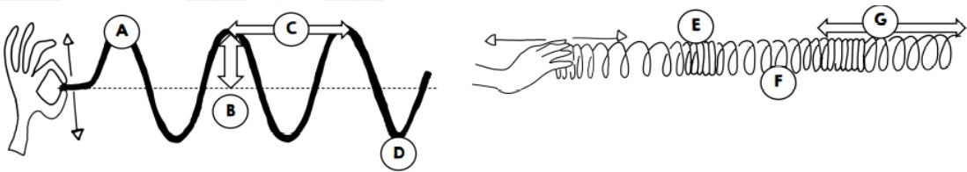​

At which point is the Compression located?

1. ​

At which point is the Wavelength located?

1. ​

At which point is the Crest located?

20. The number of wavelengths that pass a point each per second is: